

|  |  |  |  |  |
| --- | --- | --- | --- | --- |
| Image result for happy easter images |  | |  | | --- | | Rangitaiki News  March 2018 | |  | |
|  |  |  |
|  |  | March 26th |

# Local News and Events

*Taupō District Council Long Term Plan 2018-2028.*

***​​​****Every three years Taupō District Council develops a Long Term Plan (LTP) that outlines the services, key products and initiatives it plans on delivering for our community. It sets the vision and direction for our district for the next 10 years.*

**Come along to the Rangitaiki community hall on Wednesday 4 April, 5pm to 6:00pm where Councillors and staff will outline the key things they want feedback on from the community.  This will be a great opportunity to tell them the things you support, or the things you don’t, and to help guide their future decision making.**

*You can access the plan online at* [*taupo.govt.nz*](http://taupo.govt.nz) *and hard copies are available from the council customer service centre at* [*46 Horomatangi Street*](https://maps.google.com/?q=46+Horomatangi+Street&entry=gmail&source=g)*.  There will also be copies available on the night. Submissions close April 16, 2018 at 5pm*

**Honda Kids Campout**

**Lochinver Station over Easter weekend.**

**Ring Lochinver if you would like more information.**





Playgroup

**Every Wednesday at 10.30** in the community hall.

The cost is $2.00 to cover the power.

We have had a great turnout lately.

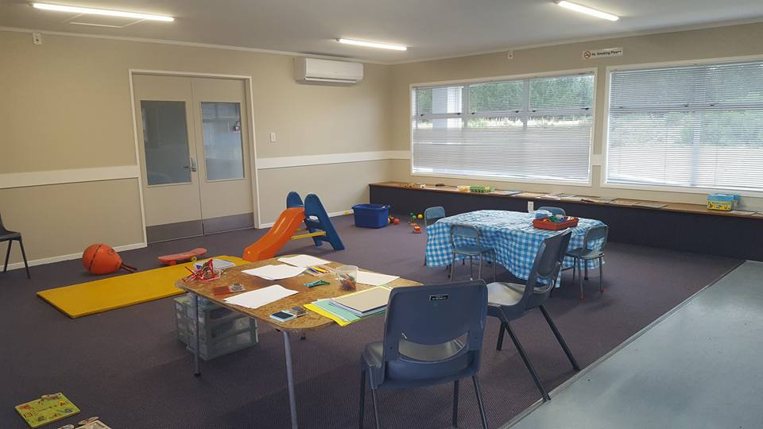

Day Care

*We have had request for anyone providing day care/crèche in their own home in the area. If this sounds like something you could do, please let the school know and we will pass the information on.*

Sponsorship

**Do you know anyone who would like to sponsor the printing of this community newsletter?**

Would you like your newsletter emailed out to you? Just email or ring the school and let us know.

I

*Your advertising could go here*

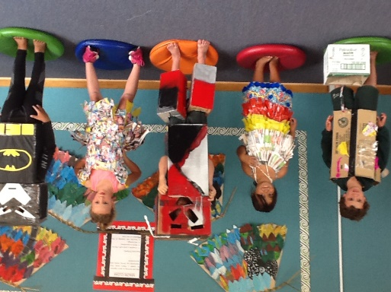School News

**Photos from Pasty’s farewell Tea Party on Tuesday. She will be missed. I know she will enjoy her retirement.**

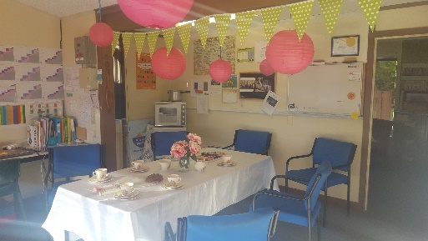



*Anything to sell?*



**Photos from our wearable arts fashion parade. The winner was.. Alexis-jane**



***If you have anything to add to our newsletter we would love to add it for you. Just let us know.***

**Thank you to Shannon from the TDC for coming out to judge.**

