Term 4 News letter
15/10/2021

It’s so nice to see the blossom on trees and sit outside and feel the warmth of the sun on my face. I love this time of the year. I love to watch the baby lambs and calves in the paddocks as I drive out to school. Amongst all the unknown in our world at the moment it gives me a sense of peace and hope that all will be fine.

Summer Uniform
Students can now start wearing their summer uniform to school. This comprises of a skort (for girls) and shorts for boys, their polo shirts and a sunhat. We have zillions at school if you don’t have a sunhat.

Term 4 already.. wow!
This term is going to go fast with only 9 weeks till we finish school for 2021.
Over the holidays Beatriz and Lucy have been busy at school building a new living tepee. This will provide a lovely restful place to read and relax as well as a natural climbing frame for plants. Thank you ladies .

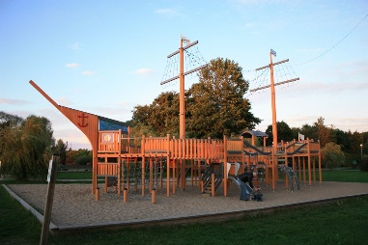
Ship Ahoy!
We have applied for a grant to build a new playground to replace the old fort that is slowly falling to bits and not as safe for our tamariki as it should be. We have also entered a competition run by Mitre 10 for a playground makeover. Our new playground will be a pirate ship and the children will design it. This project will be a focus for 2022 and ties nicely into the design aspect of the STEAM (Science, Technology, Engineering, Art and Mathematics.) learning we are doing at the moment.

Pet Day
We have decided to have Pet Day on Friday the 19th of November. I have been in contact with a couple of parents from Opepe that would like to bring their children along and enter the calf and lamb competitions.
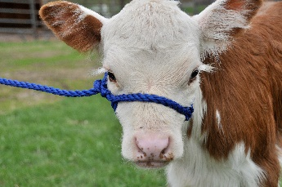
More information will come home soon about this fun day. In the meantime start training those calves and lambs.

Term 4 Calendar
19th -22nd October I am away having an operation on my hand. Mrs Patterson, Mrs Drake, and Lucy will be teaching the rest of the first week.
25th October Labour Day NO SCHOOL
27th October Board Meeting 6.30pm staffroom. All welcome
28th October Andrea to meet with ERO. (Education Review Office)
19th November PET DAY
24th November Board Meeting 6.30pm in staffroom.
3rd December Staff and Board Xmas party.
3rd December all reports finished.
8th December Board meeting 6.30pm in staffroom.
9th December “Triple A day”
10th December School Xmas Concert in the hall. 6pm onwards
15th December Last Day.

Triple A day is a special day out with me for the student who has the shown the best
Attitude to school life, Attendance at school and steady Achievement across the curriculum.
This award is very special and time is taken to work out who that student is each year.
The student gets to have a fun adventure for the entire school day including lunch.

Library
The Taupo Library is getting a makeover and the library liaison ladies came to visit us recently. The children wrote fantasy stories for a competition the town library were having all about “our best time at the library” and we sent these in. They were very, very good!.
The lovely liaison ladies came to see what we would like for our country community to get them reading. We talked about access and time and decided to bring the town library to school. We will have 100 books from the town library each term at school to loan out to our community. I have included a questionnaire to see what topics you would like books on. These books are in our library now so when it gets to level 1 be sure to pop in and borrow away.

Learning
Our term focus is “Our Future”. This focus is a good time to teach the children about the Covid-19 facts and how things are changing and different to keep us all safe and healthy.
If you haven’t seen ‘Nano girl’ on YouTube she is very good.

https://youtu.be/phNY-tEJRDk
https://youtu.be/EY35E9huYvI

We will look at sustainability and our part in making the world a better place.

We will also look at our learning progress this year and goal setting for 2022.

Lessons will continue in STEAM with MR G and our weekly virtual learning class for te reo Maori.

We hope to start up the playgroup again this term, as soon as we are in level 1.

Covid-19
Please remember to sign in with the school QR code if you need to pop in. Wear a mask if you have been around other people. Fill in the health questionnaire if you have been away from school for a while.
At school we take the health of your children very seriously and clean the desks and hard surfaces with Janola each day. We teach your children to cough in to their elbow and to wash their hands well. We will also check in with our students’ mental well-being as this is a stressful and uncertain time for some and sometimes children need to be taught coping strategies for feelings of anxiety and worry.

Stay safe and well
Andrea Haycock
Princpal

