Rangitaiki School

He iwitahi e mahi ana

28/1/2022

Kei aku nui, kei aku rahi, tēnā koutou katoa i roto i ngā āhuatanga o te wā.

School starts on Wednesday 2nd of February 2022

Welcome back after what we hope has been a wonderful summer for your whānau.

Our team is feeling refreshed and ready to go for the 2022 year and can’t wait to welcome everyone back onsite.

In regard to COVID-19 we have moved fully into the new traffic light framework for all our school and kura activities and events this year. It is good to know that at Red setting, we are able to support everyone learning onsite.

Events and activities
It is for once very good to be such a small school as we don’t have a lot of the large gathering issues that face bigger schools. All our events and activities at school can go ahead and we are waiting to hear about swimming lesson that are at the A.C Baths in May.

Ventilation
We have used the Ministry of Education self-assessment tool to review all our ventilation in readiness for the start of the year. Providing good old fashioned fresh air remains the most important thing we can do in our learning spaces to minimise risk for ākonga and kaiako (and the same goes for you at home). We will also be receiving a CO₂ monitor in the coming weeks to further support our ventilation plan

Omicron and testing
We have all seen the very large numbers of cases overseas and we will very likely see much larger numbers of cases in Aotearoa than we have previously experienced in the last two years. While Omicron is more transmissible than previous strains, most people who get COVID-19 will have a mild to moderate illness and will fully recover in their own home.

However, some of our community who are immune compromised, are ill or have other vulnerabilities, even when they are fully vaccinated, could be more affected by Omicron. So, we all need to continue to play our part to minimise the spread of the virus.

In regard to testing, the health system currently has capacity to process 40,000 PCR tests a day. PCR testing is the most accurate test for COVID-19 and will continue to be used while New Zealand is in the stamp-it-out phase.

Rapid Antigen Tests (RATs) will begin to be used more widely over time. They are not as accurate as PCR tests and this means that some people who do have COVID-19 will get a negative test result back. There are currently 4.6 million RATs in the country and 10s of millions ordered.

If you are symptomatic or need to be tested to access a workplace or service, you will be guided at the time on which test is best for you.

Face coverings

It has been mandated that staff and children in Years 4 – 13 must wear face coverings when inside at school when we are at Red, however we have been advised that ‘if your child is in year 4 or above but is in a class with children in Year 1,2,or 3, they are not required to wear a mask’.This also applies to staff that are in the class with mixed year groups like we have.
If you would like your child to wear a mask, we will of course support you in this.

Any parent entering the school however must wear a mask.

Public health advice is that an appropriate face covering will fit snugly and seal well around facial contours. This can include single use, disposable masks (medical masks) and re-usable fabric masks with three layers.

Don’t worry if you don’t have these specific types of face coverings, as public health experts also say that any face covering is better than no face covering.

Vaccination for five- to 11-year-olds
Vaccination including a booster shot, remains an important tool to help prevent the most serious harm from the COVID-19 virus. If children and young adults who have been vaccinated do develop COVID-19, they are far less likely to get seriously ill and less likely to transmit the virus to others.

The free five- to 11-year-old vaccination programme is now underway and more than 100,000 children in New Zealand have had their first dose.

There is some helpful information available to support you on the Unite Against COVID-19 website including How to book a vaccine for your five – 11 year old and some great videos on the Kids Health page that can support you to talk to your tamariki about the COVID-19 vaccine.

Managing cases in our school
We have a good contact tracing system in place so that if there is a confirmed case who has been at school while infectious, we can quickly identify who was a close contact of that person. We will then quickly advise those contacts of what they need to do.

Only if the Ministry of Health or the Ministry of Education advises to do so, would we consider closing a physical onsite school and moving to distance learning for everyone. At Red we will keep everyone learning onsite for as long as we can.

Please make sure your contact details we have on file are up to date, so we can get in touch with you if needed.

Preparing for COVID-19
You can also prepare for COVID-19, making sure you and your household have a plan and know what to do. This will mean your whānau and community can help each other if needed. Find out more here:
- Be prepared for COVID-19
- Download the COVID-19 Readiness Checklist [PDF, 121 KB]
- What to expect when self-isolating at home

Self-isolating at home because of COVID-19
Many people will be able to manage self-isolation with help from friends and whānau, but there is help available if you need it – both with health support and access to food and other essentials.
- What to expect when self-isolating at home | Unite against COVID-19 (covid19.govt.nz)
- Getting extra support if you have COVID-19 or are self-isolating | Unite against COVID-19 (covid19.govt.nz)
- COVID-19 positive – managing your symptoms | Health Navigator NZ

If you know anyone in your community affected by COVID-19 and who may need help, such as food and other financial assistance, Work and Income has a range of supports available for individuals, families, employers and self-employed people affected by COVID-19.

Work and Income support

The beginning of the year can be a tough time for parents who are faced with many costs and it is important you are aware of what assistance you may be able to get from Work and Income. These are available to people on a low income as well as those on a benefit.

Check what you might get here
- School costs
- Out of School Care and Recreation (OSCAR) Subsidy
- Other Childcare Assistance
- School and Year Start-up Payment (for people getting Orphan’s Benefit or Unsupported Child’s Benefit)
- Help with living costs (including food and rent/mortgage)

Use the links above or call 0800 559 009 to find out more, or to apply.

Getting ready to return to school
The Ministry of Education has some helpful information on their Parents and Whānau website to support your tamariki to get back to school. There is also a very important reminder about how you can take care of yourself.

If your child has a runny nose, sore throat, cough, or fever please do not send them to school as we will just be sending them home again. Anyone that develops any symptoms during school time will be sent home to keep everyone safe and healthy.

While this might all feel a little overwhelming at times, we know that all these measures will help our children return to school, reconnect with whānau and friends and do what they enjoy.

We are also here to help. Please get in touch if you have any concerns or need help in any way

Bus
As you are aware our bus service has been stopped as we don’t have the required number (8 students who use the bus) to make the bus service run. Tranzit (who have taken over Nimmons) also have a shortage of bus drivers.
I have emailed the Taupo Network Group, (a group that organise the Taupo schools bus runs) with a list of questions so we can make some decisions around where to go from here.
I understand this is going to be a real issue with our local farming families before and after school and can assure you that our school board is doing everything, we can to sort something out.
We are organising a bus meeting on Wednesday the 3rd of February. I will add more details about where and when to the school messenger page.

Uniforms
Send you children to school in their summer uniform for Term one. Check to see if you need to order some more shorts, skorts or polo shirts. We have wide brim sunhats at school if you do not have one.

School books
Lists for stationery were sent home at the end of term in 2021. Please send children to school with all named stationery on their first day.

Playgroup
Playgroup can start up again as we have under 25 people (vaccinated and unvaccinated) in one space. We will keep the playgroup children away from the rest of the school children to be extra safe, but I am excited to see all our little tamariki again.
The first one will be on Thursday the 3rd at 9.30am.

Lunches
We are continuing with our ‘nude food’ lunch boxes this year. This means as little packet food as you can. We aim to have no rubbish at school and also promote healthy whole food (less proceed food) as we can.
Children need a healthy snack for ‘brain food’ time. (fruit or nuts etc), Morning tea (muffin, biscuit, fruit etc), Lunch (Sandwich, leftovers, salad yoghurt etc )
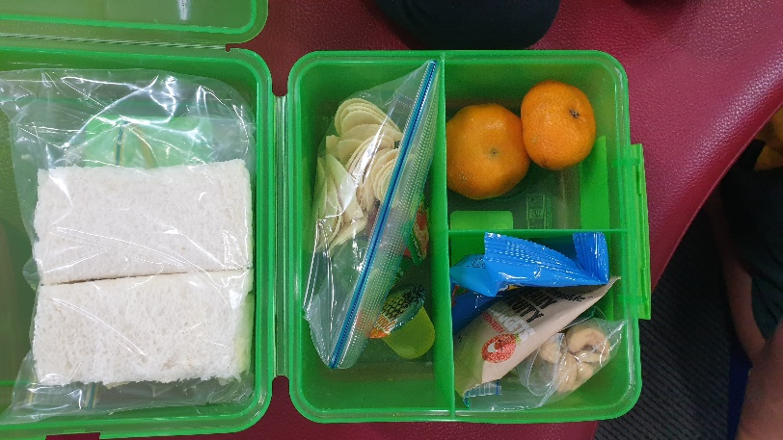
They also need a named drink bottle with water only in it.
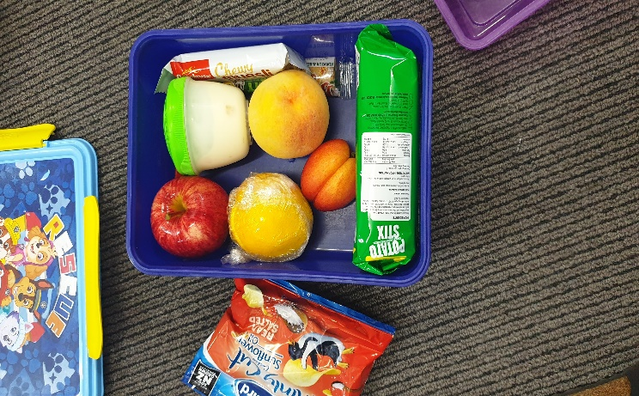

Important dates
7th February – no school for Waitangi Day
22nd February – NiaKӓӓpe Armstrong starts school
23rd February- Board Meeting. 6.30pm in staffroom (all welcome)
25th February – Unison Safe Sparks lessons at school.
15th March – Virtual Learning Te reo māori starts again.
23rd March- Board Meeting. 6.30pm in staffroom (all welcome)
1st April- Bike Taupo coming to school.
14th April – Last Day of Term
15th April – No School Easter Friday

Term Dates
Term 1 - 2nd Feb – 14th April
Term 2 - 2nd May- 8th July
Term 3 - 25th July- 30th September
Term 4 – 17th October – 16th December.

Term Focus
This term is all about the Ākonga (student). We will be looking at our body (tinana) and learning about the different parts and what makes us healthy. We will be making school rules to keep us all safe and creating some individual goals for the term.

Enjoy the last few days of the school holidays.

See you soon!

Andrea Haycock
Principal

